Nama : Muhamad Nur Alim

NIM : 18090040

Kelas : 5B

**Laporan Pratikum 5**

1. Source Code

MatakuliahValidation.php → controllers

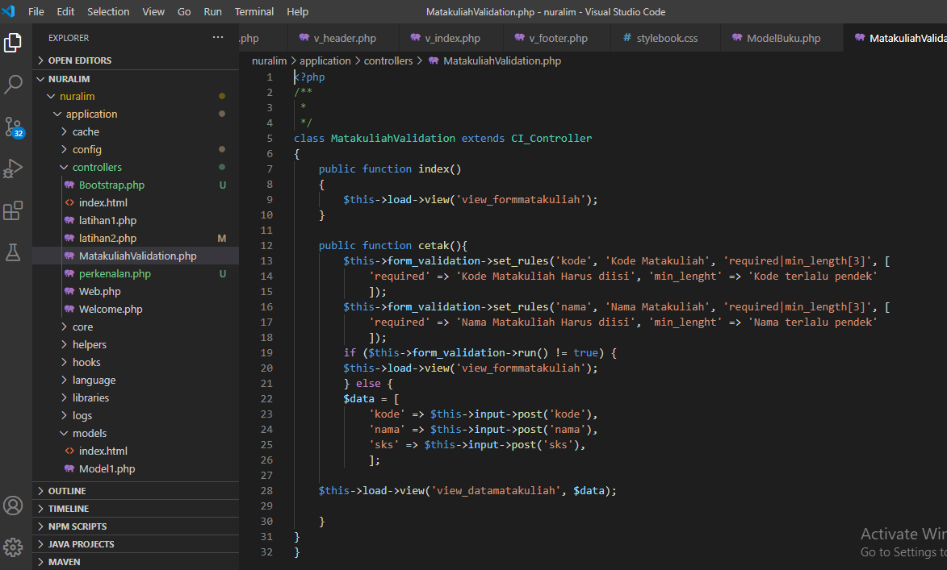

View-form-matakuliah.php → view

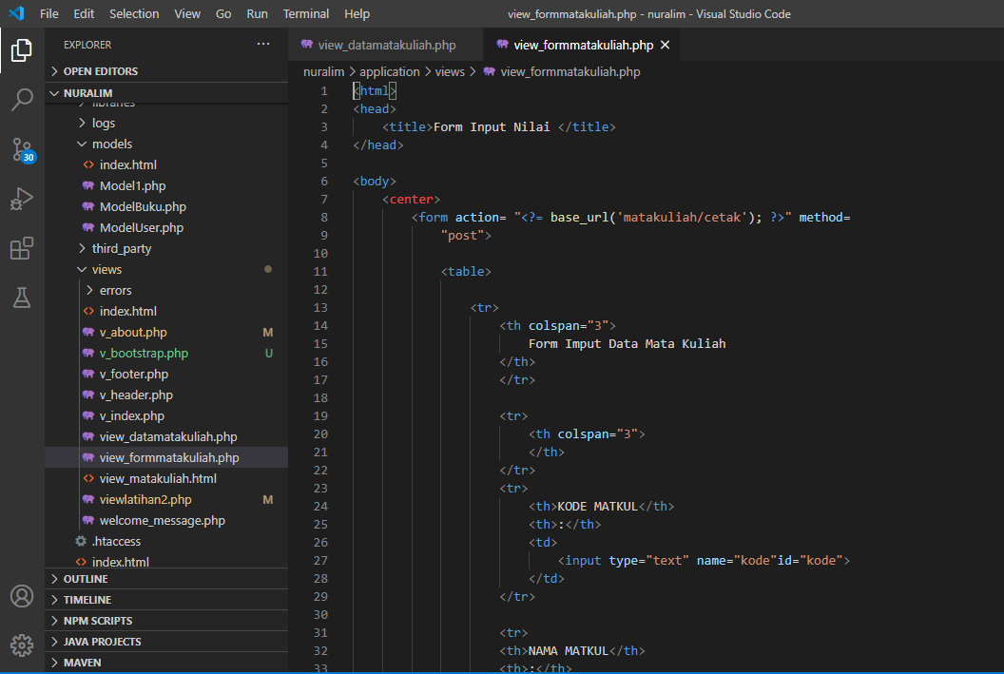

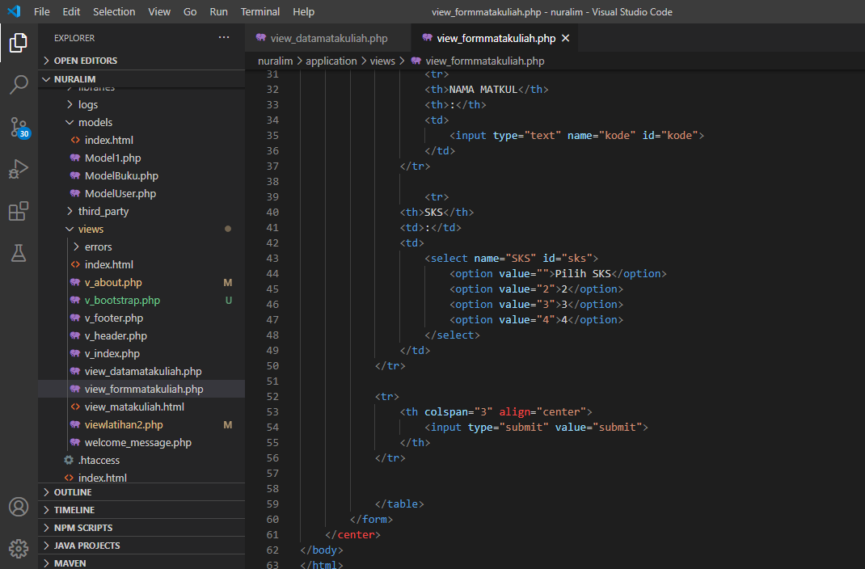

Matakuliah.php → controllers

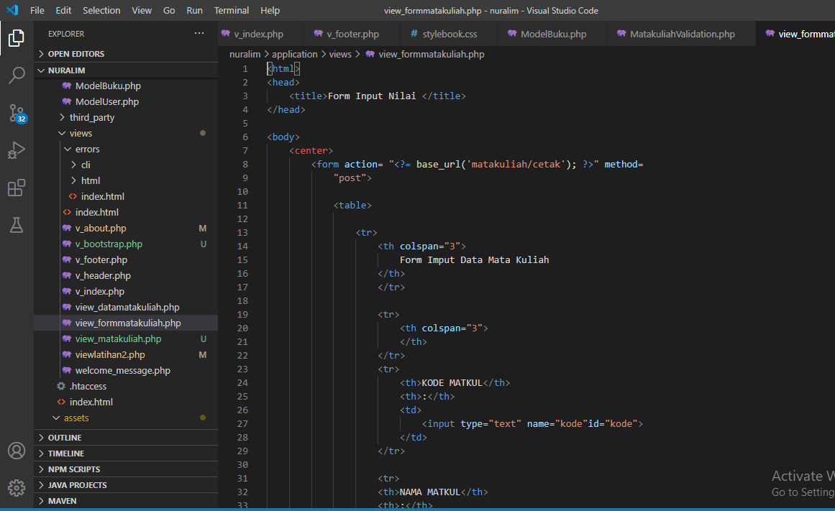

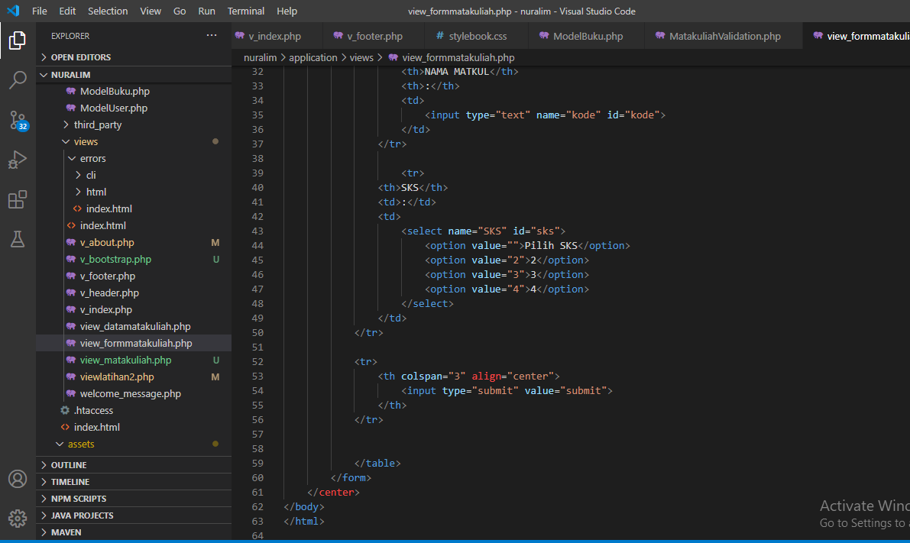

1. Capture Output Program

